**Research Report – Motor coordination, Mirror calibration and their combination***Written by Britt Reijnders*

***Contents:****1. Research Report  
2. Bibliography  
3. Appendices*

Within the scope of the given project – building a fully functional and true to nature portable planetarium – and with the given requirements by the product owner, there are a few key components to be integrated into the final product. When building a planetarium projector, efficient ways to project clear images and points on a set surface must be examined and thought of. In the case of the project designed and monitored by Jacques de Hooge, the method of projection will consist of coordination of multiple motors that turn a specific set of mirrors in the correct angles to project points or lines onto a surface with (x,y) coordinates. The requirements set by Jacques are primarily focused on the components needed for projection. There are requirements for the motor operation speed set by the group, which will be taken into account when evaluating possible solutions for mirror projection.   
From the aforementioned information and problem description, the following research question can be formulated: *What hardware components, including motors and pre-made laser reflection solutions, are suitable for being used in the previously described environment with the necessary requirements?* This question in turn generates a set of sub questions: What pre-made solutions are there that work with laser reflection or laser projection? What types of motors are there that are power efficient and fit within the limits of the project’s chosen power source? What types of motors are there that have a fast response time that matches the criteria? In what way does light projection or laser projection operate and what are the physical formulas associated with these principles?   
The definitions of certain requirements, such as power efficiency or response time, are further defined in the following paragraphs answering the respective sub questions. The first of these is mainly focused on the ways in which laser or light projection works and the physical principles that describe these phenomena.

To project light on the ceiling of a room, lasers could be pointed directly at the given coordinate. This would however be very costly and could make operating the lasers much more difficult. To combat this problem, mirror projection is a suitable solution because of its repeatability, consistency and low production costs. Mirror projection is a principle that is based on physics, mostly on the Snell-Descartes Law. This law describes the refractive index of materials, and the relation between the refractive index, angle of incidence and angle of reflection. This study will utilize the functions and formulas related to total reflection of light, which is based around the critical angle of incidence. If the angle of incidence is greater than the critical angle of a given material, all light hitting the material will be reflected in an angle equaling the angle of incidence.   
Mirrors are coated with a thin layer of silver or aluminium which automatically reflects light rays. The main part of the research into the Snell-Descartes Law will focus on total reflection, since the critical angle of a mirror is anything greater than an angle of 0 degrees.   
The principle of reflection as described before must be translated into a working product that can project a single laser beam onto a set point in a coordinate grid. To project onto both an x and y axis, the unit of projection will need two mirrors to project onto both aforementioned axes, which in turn will be controlled by a set of two motors that can rotate quickly and can project points onto the grid without laser trails forming.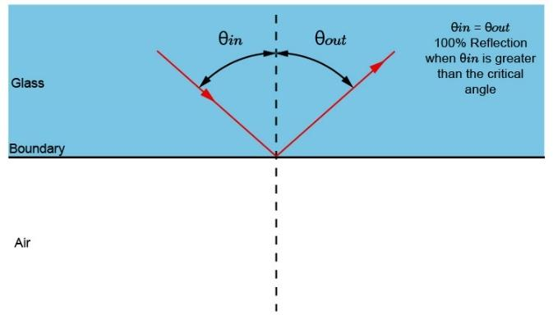

Mirror rotation cannot be achieved using hardware other than motors, excluding the pre-made solutions for projection. Motor response times must be as small as a single millisecond to project points without interconnecting lines. There is a small set of motors that can respond and rotate in a span of milliseconds, including servo motors and DC motors. Stepper motors can respond in milliseconds, but their rotation time is slower than servo and DC motors. This is the reason stepper motors will not be considered in this research paper. As a reference, a generic 6V DC motor will be compared to a 5V SG90 Micro servo motor. These motors serve as reference points, the final motors may differ from the two types chosen here.  
The 6V DC motor draws an amperage of 190 milliamperes when operating without any load. The maximal amount of amperage it can draw is around 250 milliamperes. The 5V SG90 Servo draws a variable current based on the mode it is in (See appendix 1B). The current in the idle state is 5 milliamperes, whereas the current in the stall mode is 700 milliamperes. When there is no load on the servo, the current is 100 milliamperes. Assuming the projector will not stall the motors, the current for the stall mode will not be taken into consideration when comparing motors. Since the weight of the mirrors is smaller than the maximal load both motors can handle, weight will not be taken into consideration either.   
Purely focusing on the current drawn by both motors, when comparing both, the servo has a considerably lower current drawn in amperage when operating without load. When idle, the servo motor draws a minimal amount of current that can be neglected. Based on the recorded results, the best motor to implement would be the servo motor because of its low current draw when rotating. Based on this knowledge, we can investigate existing mirror projection products that implement servo motors.

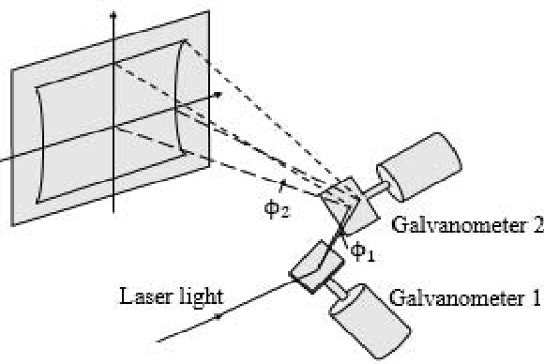When looking at existing laser projectors, one of the most implemented parts is the galvanometer. This device was originally used to measure voltage from an electrical input. The mechanism would bend the needle using a magnetic field and measuring coil based on the amount of voltage coming from the electrical input. In modern uses, the galvanometer still rotates based on electrical input, but the measuring of the voltage is left out. This has turned the galvanometer from a sensor to an actuator. Galvanometers in laser projection are often comprised of a servo motor that rotates the mirrors around a certain axis, a mirror that projects a laser into a given angle (as described in the first paragraph) and a power source. To project lasers onto a surface with only an x axis, one galvanometer is required. To project multiple axes onto a surface, two galvanometers are required. Galvanometers are accurately calibrated, but they lack in affordability. Galvanometer sets can cost upwards of €60 - €80 per two, whereas servo motors can cost as little as €1. The maximal budget for the motors is €60 per motor unit. This would mean that a single galvo would immediately reach the top of our budget. When weighing both against one another, the fact that galvanometers are calibrated beforehand makes this product the most suitable solution for the projector. Servo’s need a lot more work before being able to integrate them into the design, the mirrors first have to be attached firmly and correctly to servo’s and have to have been tested before being able to calibrate and implement them.

In short, certain motors are suitable as a base for laser projection devices. Galvanometers are the prefabricated versions of the servo-mirror contraption and are more accurately calibrated. As such, in this project the best component to use would be the galvanometer because of the ease of implementation and precision. The laser projection would be based around Snell-Descartes Law and the principle of total reflection to reflect lasers from a mirror onto a surface in a predetermined angle, to produce accurate and precise images onto the ceiling. This is to be expected of the projector, and will be tested, implemented, and presented in the coming period.

**Bibliography**

Totem (2018) – Electric Motor Comparison: Stepper versus Servo versus DC  
[*https://totemmaker.net/blog/electric-motor-comparison-stepper-vs-servo-vs-dc/*](https://totemmaker.net/blog/electric-motor-comparison-stepper-vs-servo-vs-dc/)

R. Nave (Unknown) – Total Internal Reflection  
[*http://hyperphysics.phy-astr.gsu.edu/hbase/phyopt/totint.html*](http://hyperphysics.phy-astr.gsu.edu/hbase/phyopt/totint.html)

MammothTheory (Unknown) – Why Total Reflection is always slow to fast  
[*https://mammothmemory.net/physics/refraction/why-total-internal-reflection-is-always-slow-to-fast/why-total-internal-reflection-is-always-slow-to-fast.html*](https://mammothmemory.net/physics/refraction/why-total-internal-reflection-is-always-slow-to-fast/why-total-internal-reflection-is-always-slow-to-fast.html)

Univ. of British Columbia (Unknown) – The law of Refraction  
[*https://www.math.ubc.ca/~cass/courses/m309-01a/chu/Fundamentals/snell.htm*](https://www.math.ubc.ca/~cass/courses/m309-01a/chu/Fundamentals/snell.htm)

LastMinuteEngineers (Unknown) – Control 28BYJ-48 stepper motor with ULN2003 & Arduino  
[*https://lastminuteengineers.com/28byj48-stepper-motor-arduino-tutorial/*](https://lastminuteengineers.com/28byj48-stepper-motor-arduino-tutorial/)

George Hesler (2016) - Galvanometer scanners not fast enough for your new laser or application?  
<https://precisionlaserscanning.com/2016/03/galvanometer-scanners-not-fast-enough-for-your-new-laser-or-application/>

Yellow 6V DC motor datasheet (Appendix 1A)

5V SG90 Micro servo motor (Appendix 1B)

**Appendices**

*1A*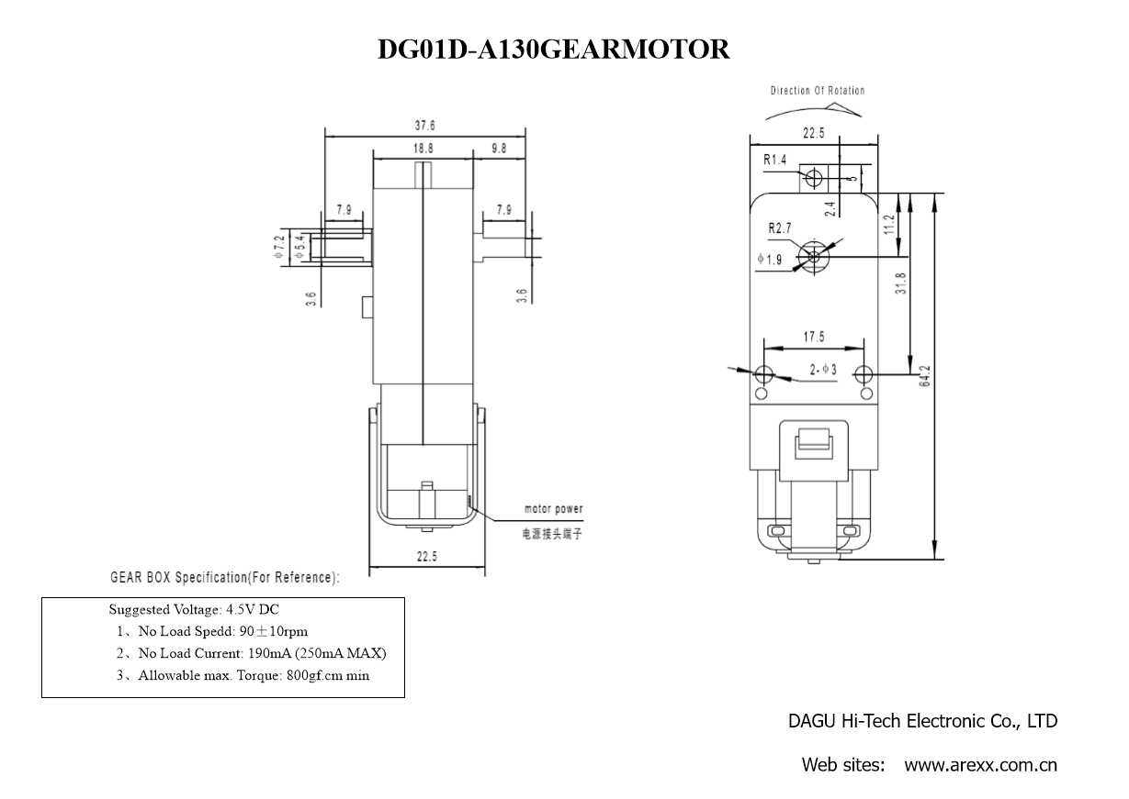

*1B*

